TERMWORK 4

NAME: name

USN: 2GI20CSXXX

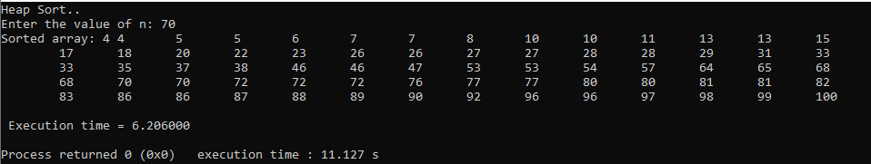

|  |  |
| --- | --- |
| **n** | **t** |
| 100 | 0.472 |
| 200 | 1.237 |
| 300 | 2.128 |
| 400 | 3.057 |
| 500 | 4.069 |
| 600 | 5.126 |